**GENERAL HUMAN BIOLOGY**

**TASK 3 – HEART DISSECTION PRACTICAL**

**NAME: ______________________________________ WEIGHTING: 4%**

**DATE: _________________________________ MARK: _____ / 40 = _____ %**

***INTRODUCTION***

The heart is one of the most important organs in the body. It continually pumps blood around the body through our arteries, capillaries and veins. It supplies the cells of our body with necessary oxygen and nutrients for the cells to function properly.

In this dissection, you will be examining a sheep heart, looking closely at the heart chambers, valves and blood vessels.

***CONDUCT DISSECTION:***

**Materials:**

|  |  |
| --- | --- |
| * sheep heart * dissecting kit – scalpel, scissors, probe, tweezers * dissecting board and safety equipment |  |

**Procedure:**

**Initial examination**

* Collect equipment listed above.
* Inspect the sheep heart and identify the left and right side of the heart. Remember the left side of the heart should be on your right side as you look at the heart.
* 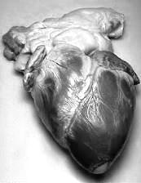Position your heart on the dissecting board matching the diagram.
* Locate the apex of the heart and measure the length of the heart from top to bottom.

Record the length: __________________ (1 mark)

* Lay the heart with the apex closest to you and the groove with a blood vessel travelling diagonally from the right side of the wide part of the heart to a point just above and to the left of the apex.
* You should be able to locate some openings into the heart. These are the arteries and veins that carry blood to and from the lungs and to and from the body.

**Dissecting the right atrium**

* Insert your probe into the superior vena cava. This should be on the right side of the top of the heart. This is the right atrium.
* Remove the probe and insert the dissecting scissors/scalpel and cut down through the heart until you reach the bottom of this chamber.
* Locate the valves that separate the atrium from the ventricles.

**Draw a diagram of the heart in the space below** (3 marks)

1. What is the purpose of these valves? (1 mark)

____________________________________________________________________________________________________________________________________________________________________

**Dissecting the right ventricle**

* Continue using your scissors/scalpel to cut down through the heart valve into the right ventricle.
* Locate the valves of the pulmonary artery and cut upward through this until you find the valves of the artery.

**Dissecting the left atrium and ventricle**

* Insert dissecting scissors/scalpel into the blood vessel located at the top of the heart. This is the pulmonary vein. Cut down through the wall of the atrium until you reach the apex.
* Open the left atrium and examine the valve that separates the atrium from the ventricle.
* Examine the ventricle, especially the walls.

1. What is different about the left ventricle compared with the right ventricle? (1 mark)

____________________________________________________________________________________________________________________________________________________________________

* This is the end of the dissection. Dispose of the heart as instructed and place all dissecting equipment in the appropriate container.
* Wipe down bench with disinfectant and wash your hands.
* Complete the questions below:

Process, evaluate and communicate findings

**Questions:**

1. Label the following diagram of the heart. Using coloured pencils, colour parts of the diagram of the heart and use arrows to show the flow of deoxygenated blood (blue) and oxygenated blood (red) through the heart. (13 marks)

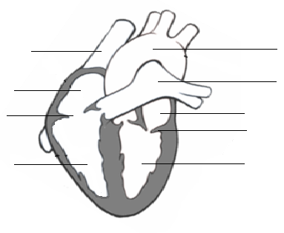

1. Where does the blood from the right atrium come from? (1 mark)

__________________________________________________________________________________

1. Where does the blood from the right ventricle go to? (1 mark)

__________________________________________________________________________________

1. Where does the blood from the left atrium come from ? (1 mark)

__________________________________________________________________________________

1. Where does the blood from the left ventricle go to? (1 mark)

__________________________________________________________________________________

1. The heart is known as a double pump. Explain why it is known as a double pump. (3 marks)

____________________________________________________________________________________________________________________________________________________________________

1. Are there any valves in other parts of the circulatory system? If so, where? (2 marks)

__________________________________________________________________________________

__________________________________________________________________________________

__________________________________________________________________________________

__________________________________________________________________________________

1. Compare the valves separating the right chambers of the heart with the valves separating the left chambers of the heart. (2 marks)

____________________________________________________________________________________________________________________________________________________________________

1. When comparing the walls of the ventricles, why is the wall of the left ventricle different from the wall of the right ventricle? (2 marks)

__________________________________________________________________________________

__________________________________________________________________________________

__________________________________________________________________________________

__________________________________________________________________________________

__________________________________________________________________________________

1. Describe the pathway that one red blood cell takes from the time it enters the superior vena cava until the time it leaves the aorta ? (8 marks)

__________________________________________________________________________________

__________________________________________________________________________________

__________________________________________________________________________________

__________________________________________________________________________________

__________________________________________________________________________________

__________________________________________________________________________________

__________________________________________________________________________________

__________________________________________________________________________________

__________________________________________________________________________________

__________________________________________________________________________________

__________________________________________________________________________________

__________________________________________________________________________________

__________________________________________________________________________________

__________________________________________________________________________________

__________________________________________________________________________________